**LAB TASK-9(24K-0555)**

**QUESTION-1A:**  
**CODE:**

#include <stdio.h>

int main() {

int n;

printf("Enter the Number of rows in terms of 'n' to print 2n+1 rows:");

scanf("%d",&n);

for (int i = 0; i < n; i++) {

for (int j = 0; j < n - i +1 ; j++) {

printf(". ");

}

for (int j = 0; j < i + 1; j++) {

printf("o");

}

printf("\n");

}

printf(". ");

for (int j = 0; j < n +1 ; j++) {

printf("o");

}

printf("\n");

for (int i = n - 1; i >= 0; i--) {

for (int j = 0; j < n - i + 1; j++) {

printf(". ");

}

for (int j = 0; j < i + 1; j++) {

printf("o");

}

printf("\n");

}

return 0;

}

**OUTPUT:**

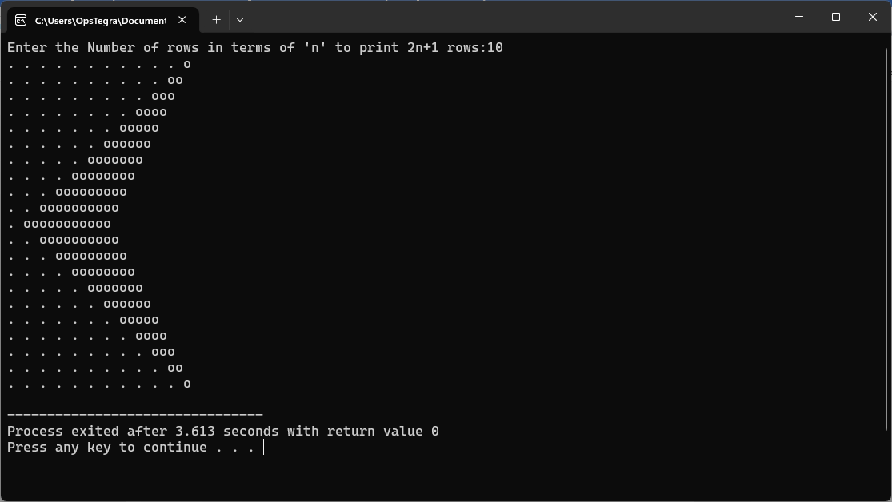

**QUESTION-1B:**  
**CODE:**

#include <stdio.h>

int main() {

int n;

printf("Enter the Amount of Rows u want to print:");

scanf("%d",&n);

for(int i=0;i<=n;i++) {

for(int j=1;j<i;j++) {

printf("%d",j);

}

for(int k=i;k>0;k--) {

printf("%d",k);

}

printf("\n");

}

return 0;

}

**OUTPUT:**

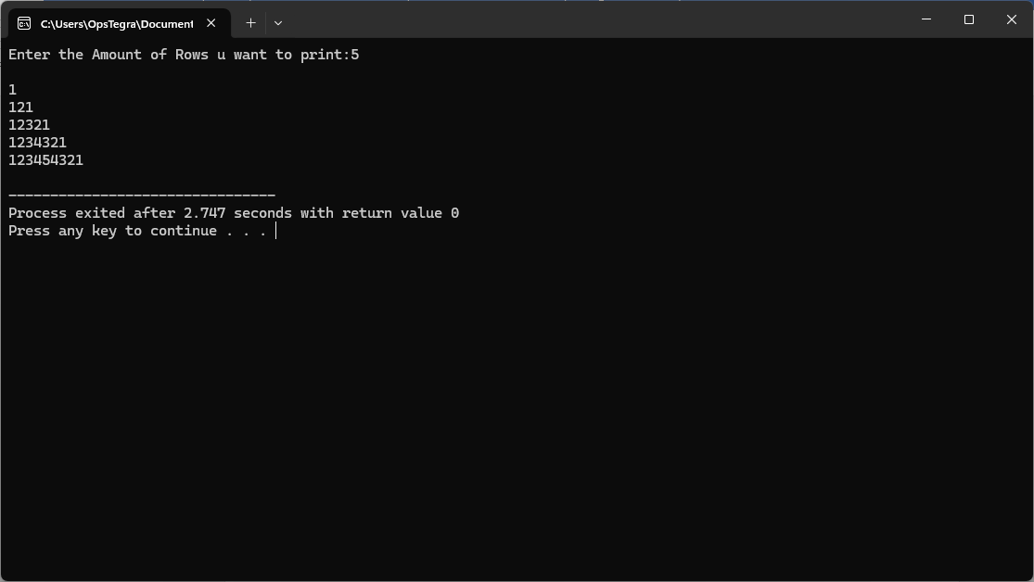

**QUESTION-2:**  
**CODE:**

#include <stdio.h>

int main() {

int bolts, nuts, washers;

int total_cost;

printf("Enter the number of bolts: ");

scanf("%d", &bolts);

printf("Enter the number of nuts: ");

scanf("%d", &nuts);

printf("Enter the number of washers: ");

scanf("%d", &washers);

total_cost = (bolts * 5) + (nuts * 3) + (washers * 1);

if (nuts < bolts && washers < 2 * bolts) {

printf("Check the Order: too few nuts and too few washers\n");

} else if (nuts < bolts) {

printf("Check the Order: too few nuts\n");

} else if (washers < 2 * bolts) {

printf("Check the Order: too few washers\n");

} else {

printf("Order is OK\n");

}

printf("Total cost (in cents): %d\n", total_cost);

return 0;

}

**OUTPUT:**

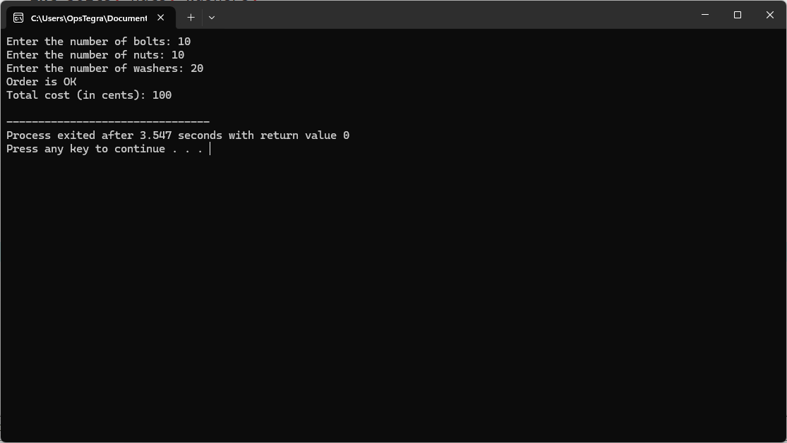

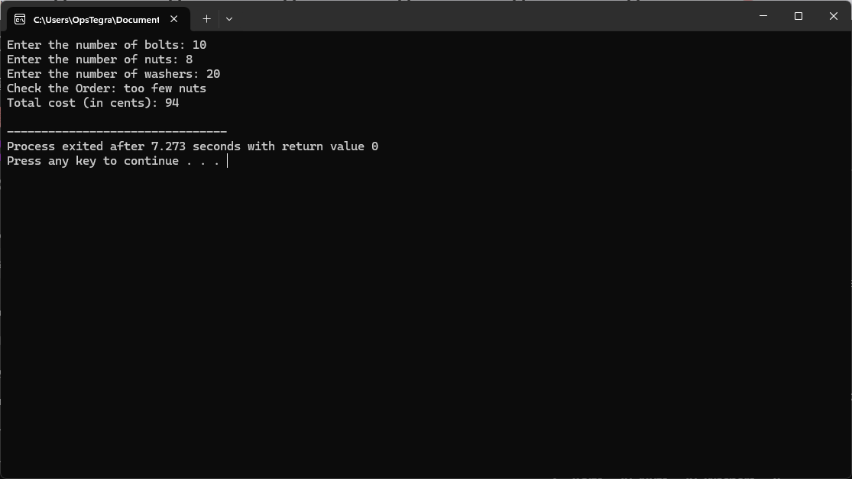

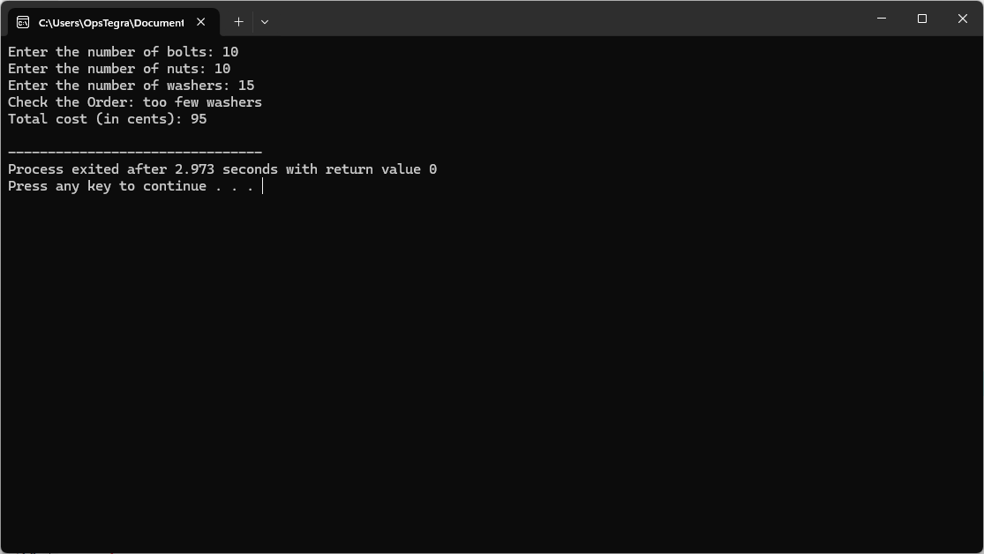

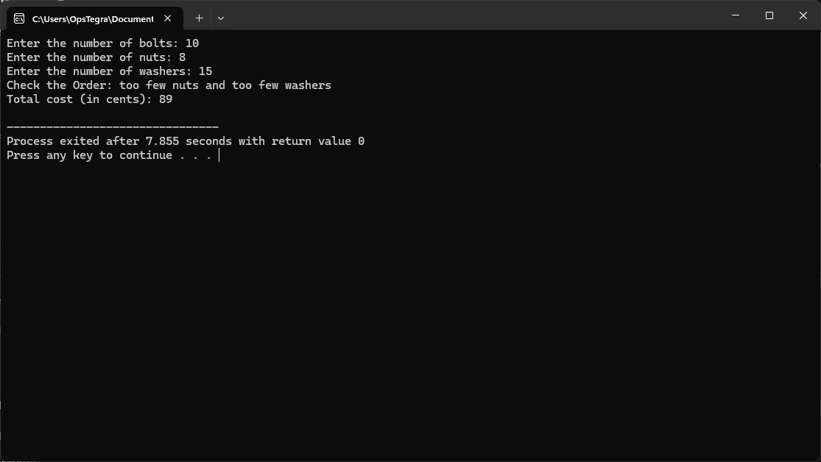  
  
**QUESTION-3:**  
**CODE:**

#include <stdio.h>

#include <string.h>

int main() {

char preset_username[] = "admin";

char preset_password[] = "1234";

char entered_username[50];

char entered_password[50];

printf("Enter username: ");

scanf("%s", entered_username);

printf("Enter password: ");

scanf("%s", entered_password);

if (strcmp(entered_username, preset_username) == 0 && strcmp(entered_password, preset_password) == 0) {

printf("Access granted.\n");

} else {

printf("Access denied.\n");

}

return 0;

}

**OUTPUT:**

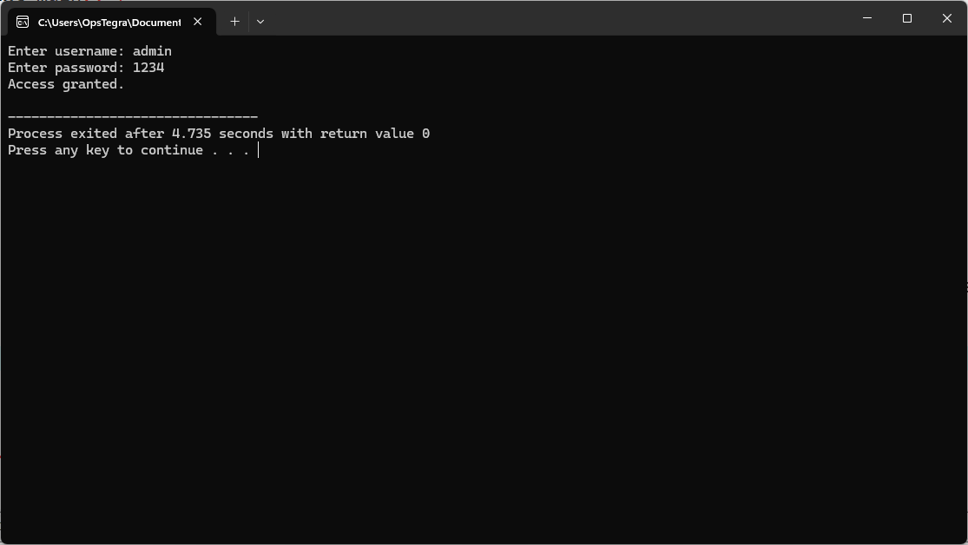

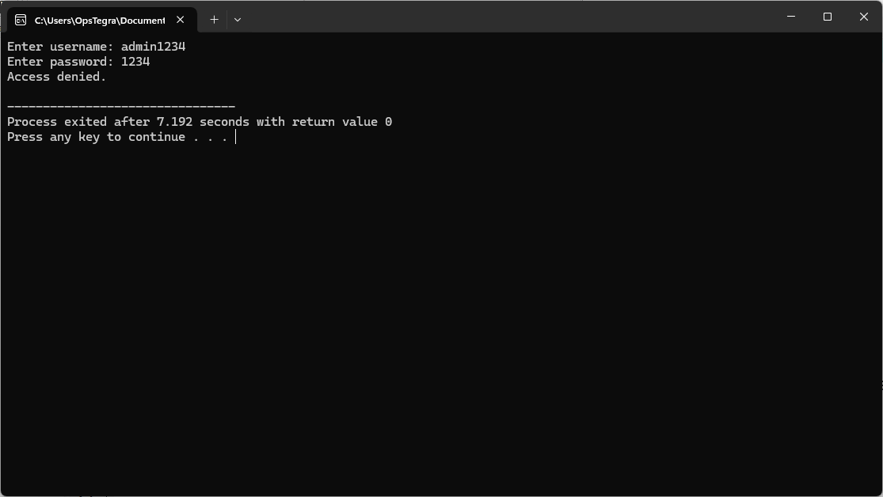

**QUESTION-4:**  
**CODE:**

#include <stdio.h>

#include <string.h>

int main() {

char students[5][20] = {"Alice", "Harry", "Charlie", "Diana", "Eve"};

char name[20];

printf("Enter a name to search: ");

scanf("%s", name);

for (int i = 0; i < 5; i++) {

if (strcmp(students[i], name) == 0) {

printf("Found\n");

return 0;

}

}

printf("Not Found\n");

return 0;

}

**OUTPUT:**

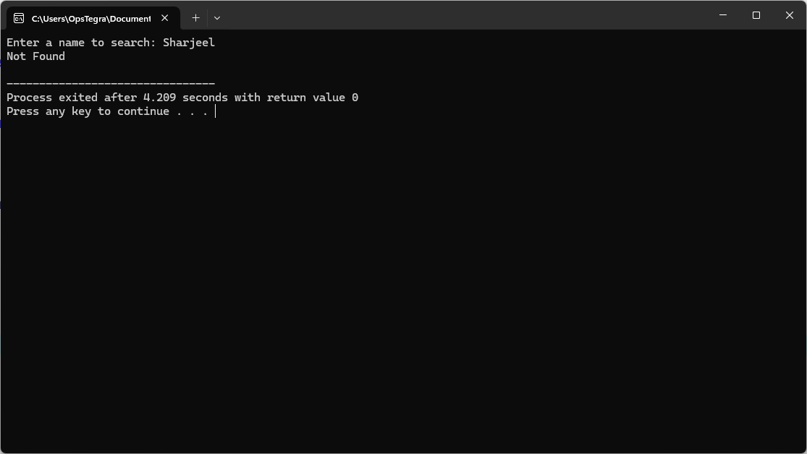

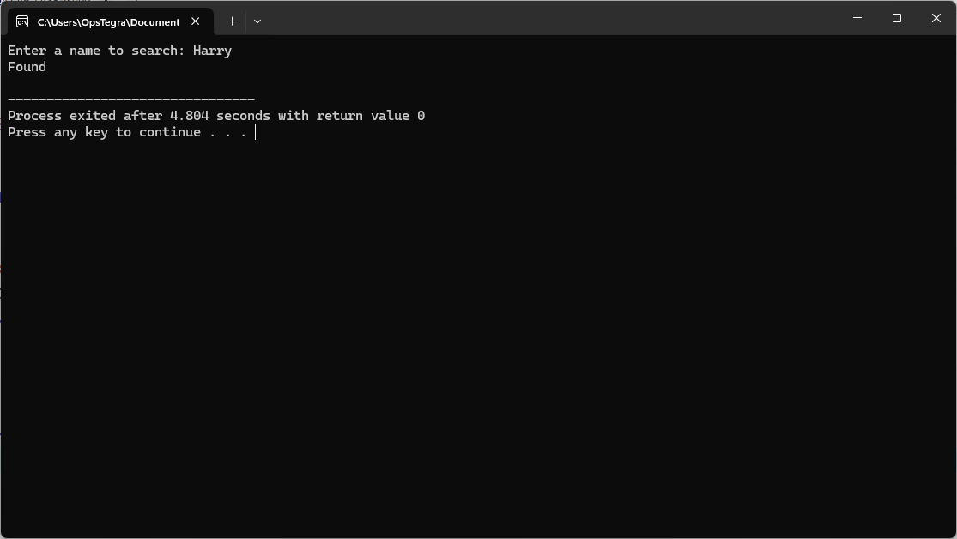

**QUESTION-5:**  
**CODE:**

#include <stdio.h>

#include <string.h>

int main() {

char plaintext[100], key[100], ciphertext[100];

int len_plaintext, len_key;

printf("Enter the plaintext: ");

fgets(plaintext, sizeof(plaintext), stdin);

plaintext[strcspn(plaintext, "\n")] = '\0';

printf("Enter the key: ");

fgets(key, sizeof(key), stdin);

key[strcspn(key, "\n")] = '\0';

len_plaintext = strlen(plaintext);

len_key = strlen(key);

for (int i = 0; i < len_plaintext; i++) {

if (plaintext[i] == ' ') {

ciphertext[i] = ' ';

} else {

int plain_text_val = plaintext[i] - 64;

int key_val = key[i % len_key] - 64;

int cipher_val = (plain_text_val + key_val) % 26;

if (cipher_val == 0) cipher_val = 26;

ciphertext[i] = cipher_val + 64;

}

}

ciphertext[len_plaintext] = '\0';

printf("Cipher text: %s\n", ciphertext);

return 0;

}

**OUTPUT:**

